Practicum 1

Opdracht 1:

Manier 1:

Manier2:

Opdracht2:

Manier1:

Manier2:

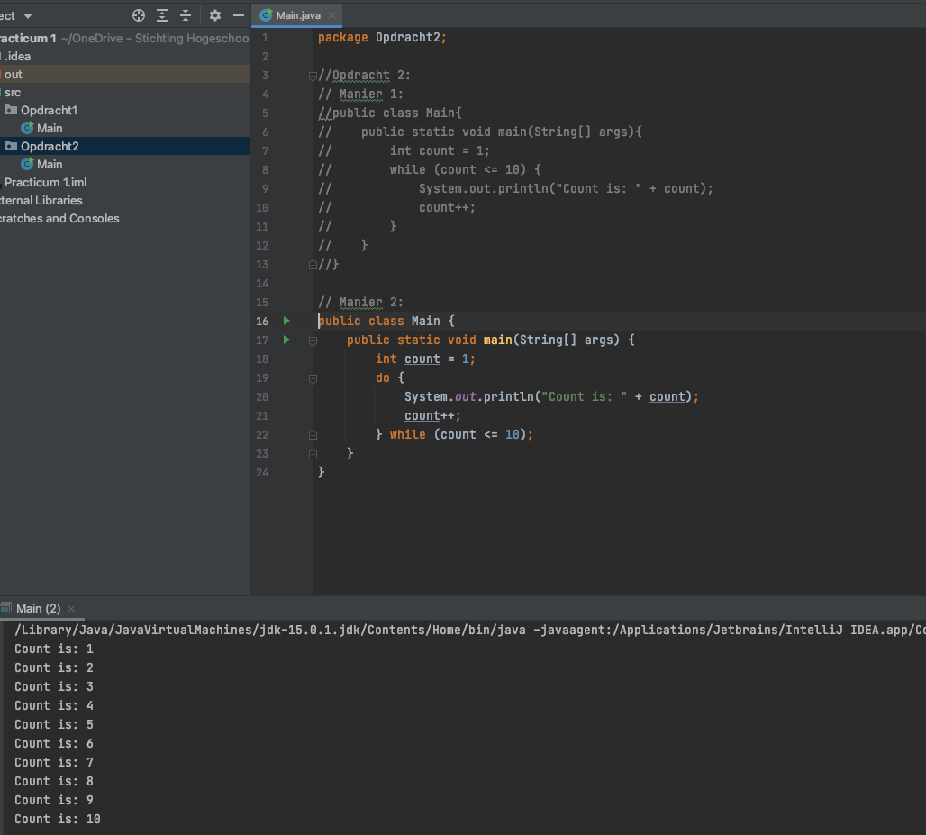

Opdracht3:

Opdracht 4:

Opdracht5:

Manier1:

Manier2:

